Test plan for
<<Neural style Transfer>>

ChangeLog

Version | Change Date | By | Description
001 | 30.10.23 | Palak Singh | Initial Draft

1 Introduction 2
1.1 Scope 2
1.1.1 In Scope 2
1.1.2 Out of Scope 2
1.2 Quality Objective 2
1.3 Roles and Responsibilities 2
2 Test Methodology 3
2.1 Overview 3
2.2 Test Level……………………………………………………………………………………………………………………………………..3
2.3 Test Completeness 4
3 Test Deliverables 4
4 Resource & Environment Needs 4
4.1 Testing Tools 4
4.2 Test Environment 4
5 Terms/Acronyms 5

Introduction
NST, or Neural Style Transfer has revolutionized the field of image processing by allowing the amalgamation of artistic styles to photographs. First introduced by Gatys et al., NST relies on a slow and iterative optimization process. However, recent advances have introduced faster and more efficient approaches, such as Adaptive Instance Normalization (AdaIN) and Johnson's method. Gatys's method, which laid the foundation for NST, uses a convolutional neural network (CNN) to extract information about the content and style of an image. This is based on minimizing the difference between the feature representations of content images and stylized images. This approach, although revolutionary, is very time consuming. AdaIN introduced a revolutionary approach by reinterpreting version normalization to quickly combine content and style from arbitrary images. It eliminates the need for laborious optimization, allowing for real-time style transfer with great flexibility. Johnson's method takes a different route by using perceptual loss and a pre-trained network for high-level feature comparison. This allows for precise training using network capabilities and real-time image transformation, giving the best of both worlds. This paper provides a comprehensive look at NST techniques and their evolution, shedding light on the future of image processing and style transfer.

Scope

In Scope

Functional Requirement:-
Image Input: The system must accept input images in various formats (e.g., JPEG, PNG) for both content and style images.

Style Transfer Algorithm: The system shall implement a neural style transfer algorithm to combine the content of one image with the artistic style of another image.

User Interface: The system should provide a user-friendly interface for users to upload content and style images and initiate the style transfer process.

Style Customization: Users can adjust parameters or select predefined styles for customization.

Output Options: Users should have options to save, download, or view the generated images.

Non-Functional requirement:-
Performance:
Speed: The system should perform style transfer efficiently, with minimal processing time.
Scalability: It should be able to handle a scalable number of concurrent requests.
Quality:
Image Quality: The generated images must exhibit high-quality style transfer, retaining content and style faithfully.
Style Accuracy: The style transfer should closely match the chosen style image.

Out of Scope

Out of scope for the neural style transfer project are advanced artistic styles, highly specialized hardware, real-time video processing, and in-depth image editing features, among others.

Quality Objective

- Ensure the Application Under Test conforms to functional and non-functional requirements
- Ensure the AUT meets the quality specifications defined by the client
- Bugs/issues are identified and fixed before go live
- Ensure that the style transfer process is optimized for efficiency and speed, allowing for rapid transformation of images while maintaining high-quality results.
- Prioritize a user-friendly and intuitive interface to enhance user experience, making it easy for users to upload images and customize style transfer.
- Ensure that the system functions correctly on a variety of devices, browsers, and operating systems to maximize user accessibility.

Roles and Responsibilities
Detail description of the Roles and responsibilities of different team members like
- QA Analyst- Palak Singh
- Test Manager- Mr. Abhishek Goyal
- Configuration Manager- Prof. Akankskha
- Developers- Ragini Rani, Kalash Jain
- Installation Team- Ragini Rani, Kalash Jain

Test Methodology

Overview

An Agile methodology is the most suitable for my project. It allows for flexibility, ongoing testing, and adaptation, which are essential for projects that involve machine learning, image processing, and AI. Agile enables you to respond to changing requirements and refine the style transfer algorithm as you gain insights from testing and user feedback.

Test Levels

The testing to be performed is black box testing.
The testing is performed by the developers team along with QA and Configuration Manager.

Unit Testing:
Scope: Individual components and functions of the neural style transfer algorithm.
Objective: To verify that each component works as intended, including layers, loss functions, and optimization steps.
Testing Approach: Developers and machine learning engineers conduct unit tests to validate the correctness of the algorithm at a granular level.

Integration Testing:
Scope: The interactions and interfaces between various components, libraries, and frameworks used in the project.
Objective: To ensure that the integration of different components does not introduce errors or inconsistencies in the style transfer process.
Testing Approach: Developers and testers assess the data flow and interactions between components and detect any integration issues.

Functional Testing:
Scope: The complete neural style transfer system.
Objective: To validate that the system functions according to specified requirements and that it performs accurate style transfers.
Testing Approach: Testers execute functional tests by providing input images and verifying that the output images meet the desired content and style transfer criteria.

Performance Testing:
Scope: Assessing the system's speed and efficiency in handling style transfer tasks.
Objective: To measure how well the system performs in terms of processing time, memory utilization, and resource consumption.
Testing Approach: Performance tests evaluate the system's response time and resource usage under various loads and conditions.

Usability Testing:
Scope: The user interface and user experience.
Objective: To assess how user-friendly and intuitive the interface is for users uploading content and style images.
Testing Approach: Usability tests involve users interacting with the system to evaluate the ease of use, clarity, and navigation of the interface.

Security Testing:
Scope: The system's security mechanisms, especially for handling user data.
Objective: To identify and mitigate potential security vulnerabilities, including data breaches and unauthorized access.
Testing Approach: Security testing includes penetration testing, data encryption checks, and access control assessments.

Compatibility Testing:
Scope: The system's compatibility with various platforms and devices.
Objective: To ensure that the system functions correctly on different browsers, operating systems, and devices.
Testing Approach: Testers verify that the system is compatible with a range of devices and configurations.

Regression Testing:
Scope: The entire system after updates or changes.
Objective: To confirm that new changes or enhancements do not introduce defects or negatively impact existing functionality.
Testing Approach: Automated regression tests are executed to validate that previously tested features still work as expected.

Test Completeness
Here you define the criterias that will deem your testing complete.
For instance, a few criteria to check Test Completeness would be
- 100% test coverage
- All Manual & Automated Test cases executed
- All open bugs are fixed or will be fixed in next release
- All content and style transfer tests have been executed, ensuring that various input images have been processed successfully and meet the defined content and style transfer criteria.
- Automated regression tests have been executed, and previously tested features still work as expected after updates or changes.

Test Deliverables

Test cases:-

Test Case | Test Objective | Test Data | Expected Result |  | Actual Result | Pass/Fail
1 | User Login | User Id and Password | Only Valid User login in the system |  | Unauthorized  User can  not login | Pass
1 | Model Training | Training data with content and style images | Model converges, successfully learns style transfer |  | Model successfully learns style transfer | Pass
2 | Inference | Test images (256x256 pixels) with varying content and styles | Generated images (256x256 pixels) exhibit desired style while retaining content |  | Generated images (256x256 pixels) exhibit desired style while retaining content | Pass
3 | Content Preservation | Generated images | Content remains recognizable |  | Content recognizable | Pass
4 | Style Transfer Quality | Generated images | Style closely matches style image |  | Style of the output closely matches style image | Pass
5 | Validate content layer | Sample content images, pre-trained model weights | Content layer produces expected feature maps |  | Content layer produces expected feature maps | Pass
6 | Validate style layer | Sample style images, pre-trained model weights | Style layer produces expected Gram matrices |  | Style layer produces expected Gram matrices | Pass
7 | Verify style transfer accuracy | Input images (256x256 pixels) with known content and style | Output images (256x256 pixels) match the desired style and content |  | Output images (256x256 pixels) match the desired style and content | Pass
8 | Verify data security | Testing with simulated security breaches | No unauthorized access or data breaches detected |  | Unauthorized  User can  not access | Pass
9 | Assess the impact of updates | System before and after updates | Previously tested features still work as expected |  | Previously tested features work accurately | Pass
10 | Image Size Verification | Test images (256x256 pixels) of various sizes | Generated images (256x256 pixels) maintain aspect ratio and content using a 3x3 kernel |  | Aspect ratio preserved, content recognizable using a 3x3 kernel | Pass

Decision Table for User Login

Conditions | Rule 1 | Rule 2 | Rule 3 | Rule 4
Username | False | True | False | True
Password | False | False | True | True
Output(e/h) | error | error | error | homepage

Decision Table for Image format

Conditions | Rule 1 | Rule 2 | Rule 3 | Rule 4
Image in png | False | True | False | True
Image in jpg | False | False | True | True
Output(e/a) | error | accepted | accepted | accepted

Test case Output Images

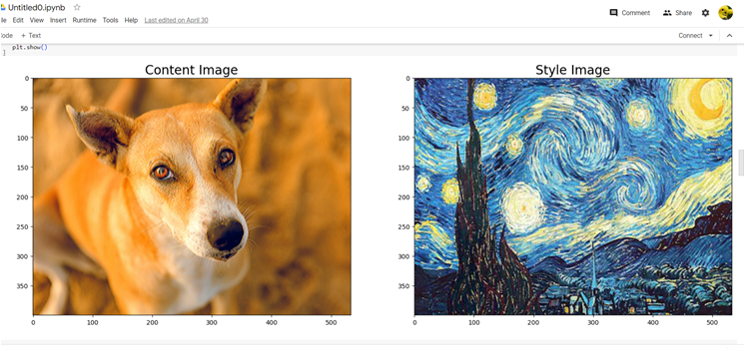

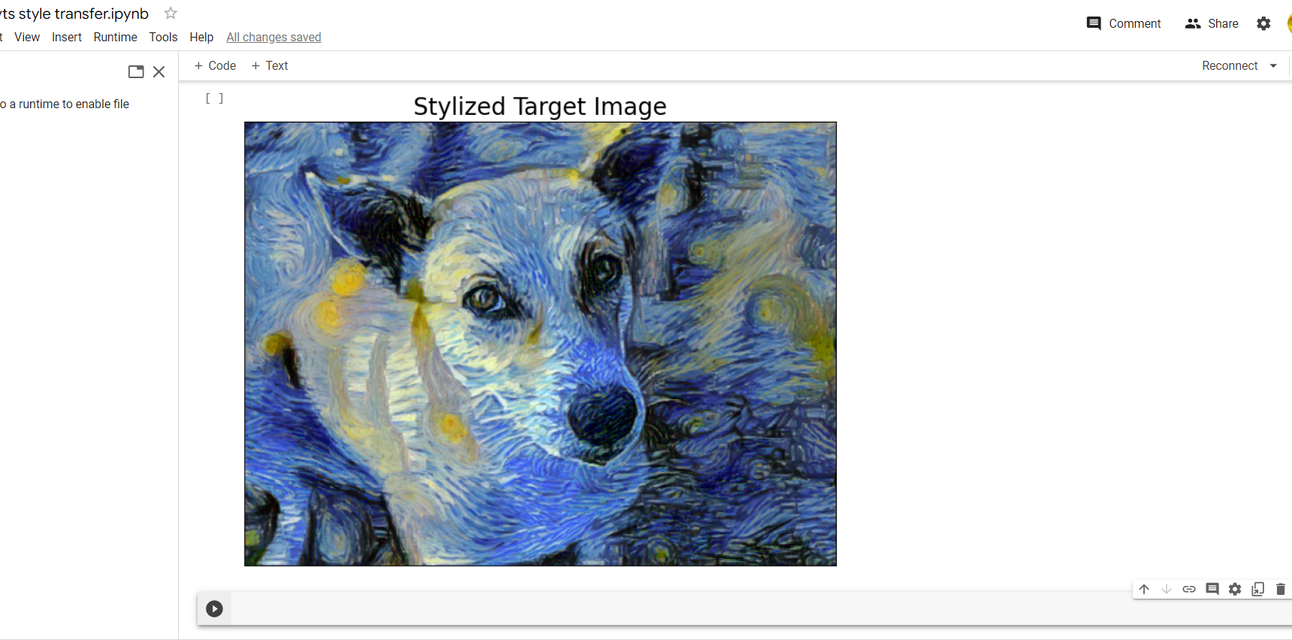

Resource & Environment Needs

Test Environment
It mentions the minimum hardware requirements that will be used to test the Application.

Following software’s are required in addition to client-specific software.

- Windows 8 and above
- Office 2013 and above
- MS Exchange, etc.

Terms/Acronyms
Make a mention of any terms or acronyms used in the project

TERM/ACRONYM | DEFINITION
API | Application Program Interface
AUT | Application Under Test

